1)Fibonacci Series using recursion.

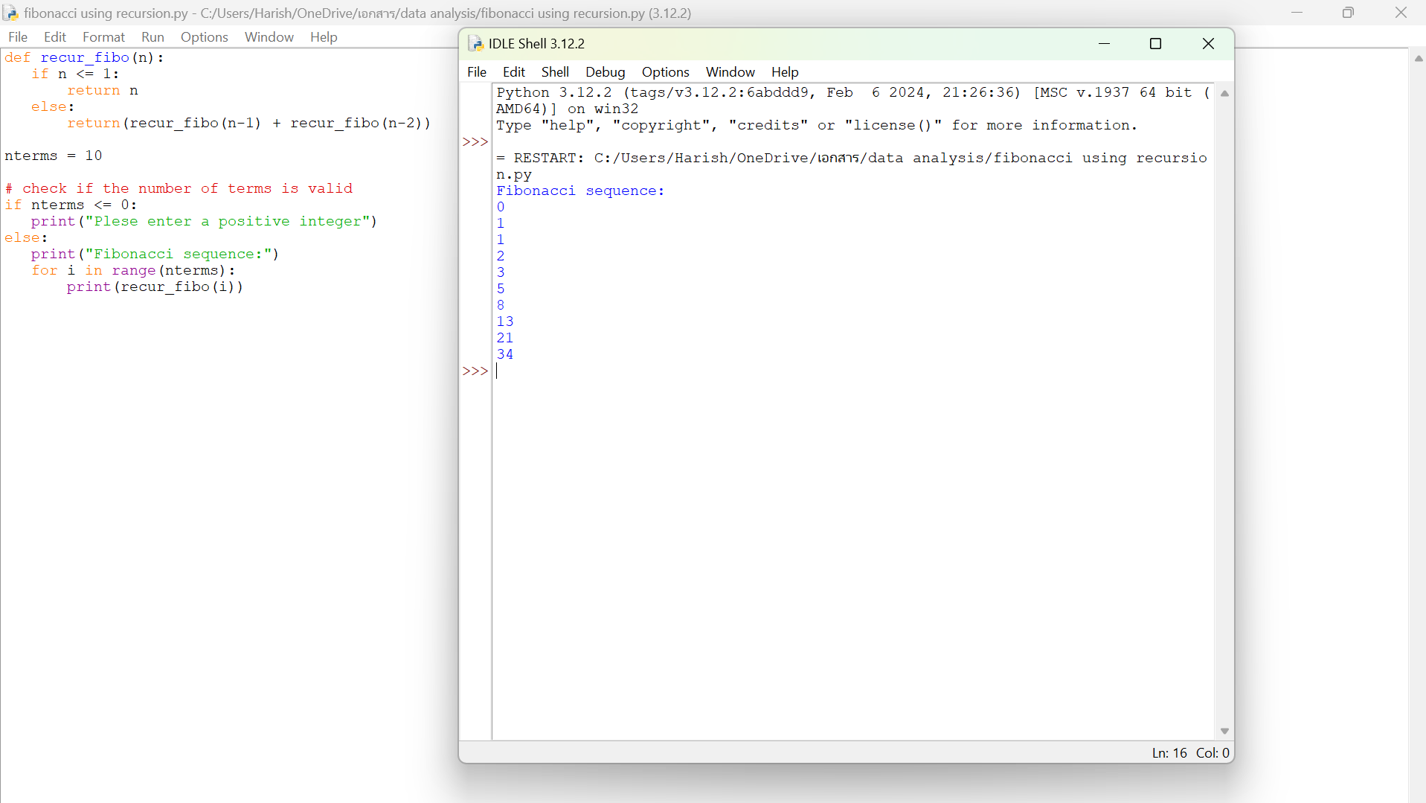

2) check the given no is Armstrong or not using recursive function.

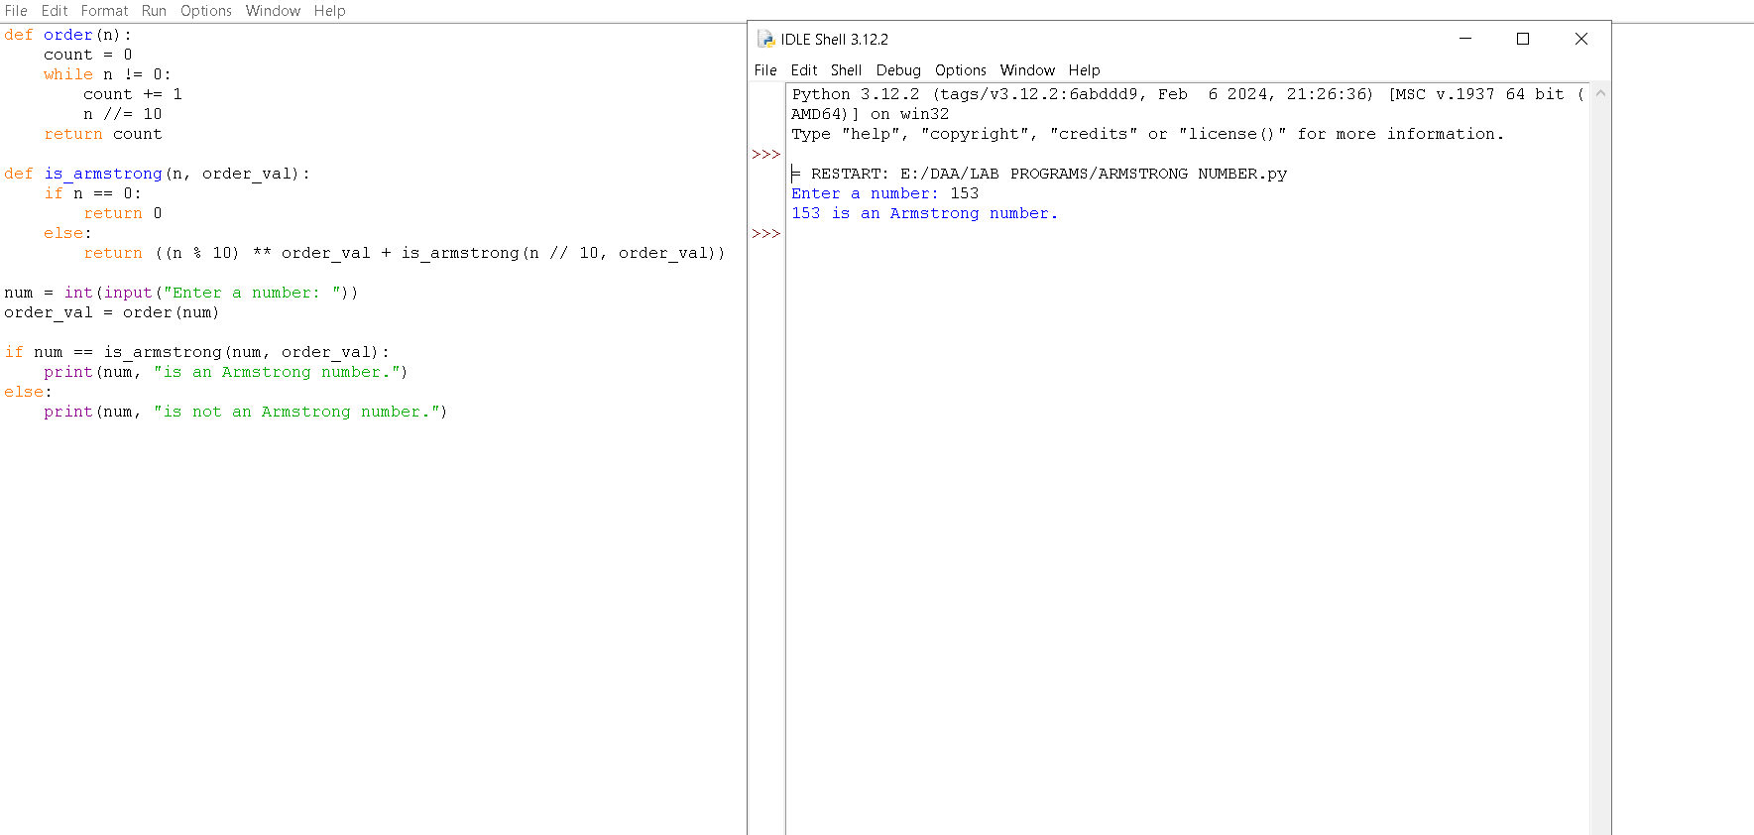

3) GCD of two numbers using recursive factorization

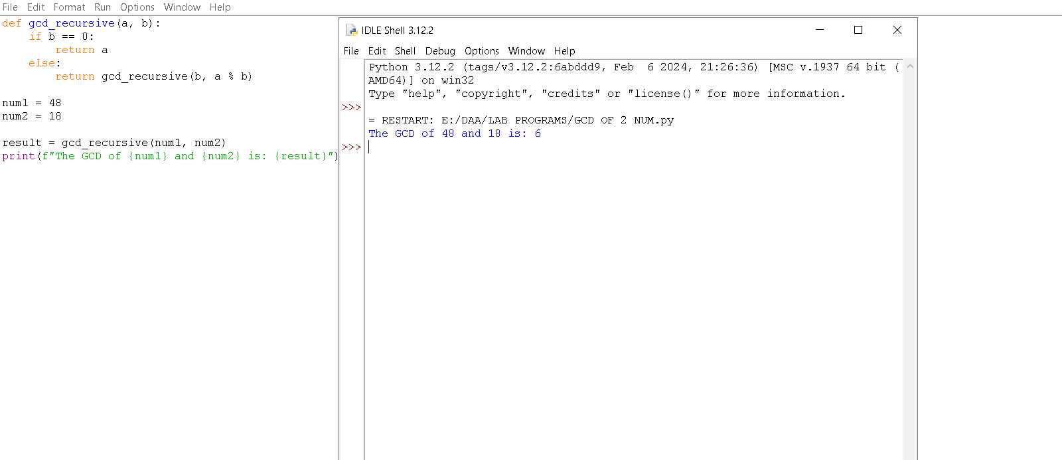

4) the largest element of an array.

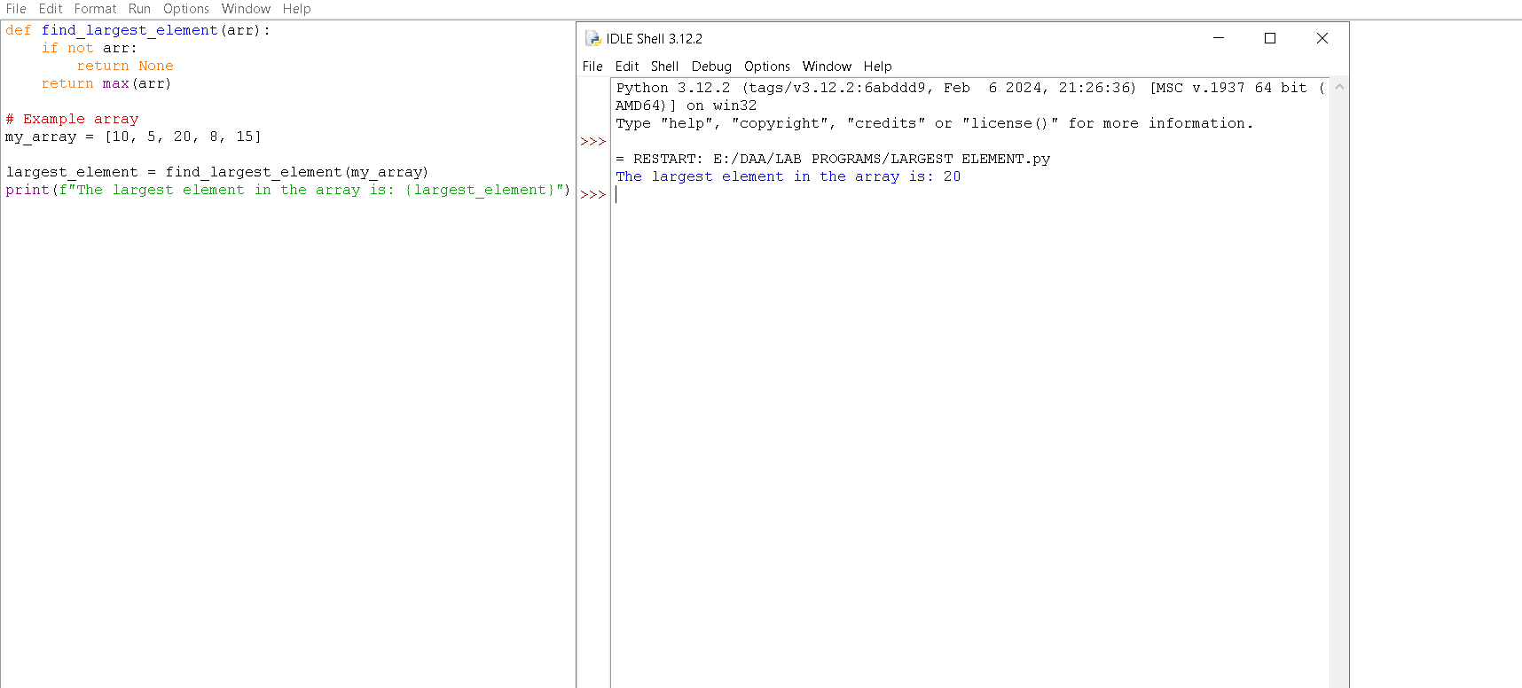

5) the Factorial of a number using recursion.

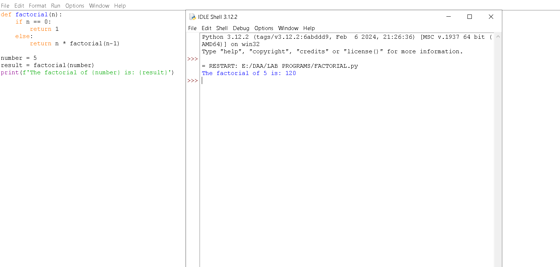

6) copy one string to another using recursion

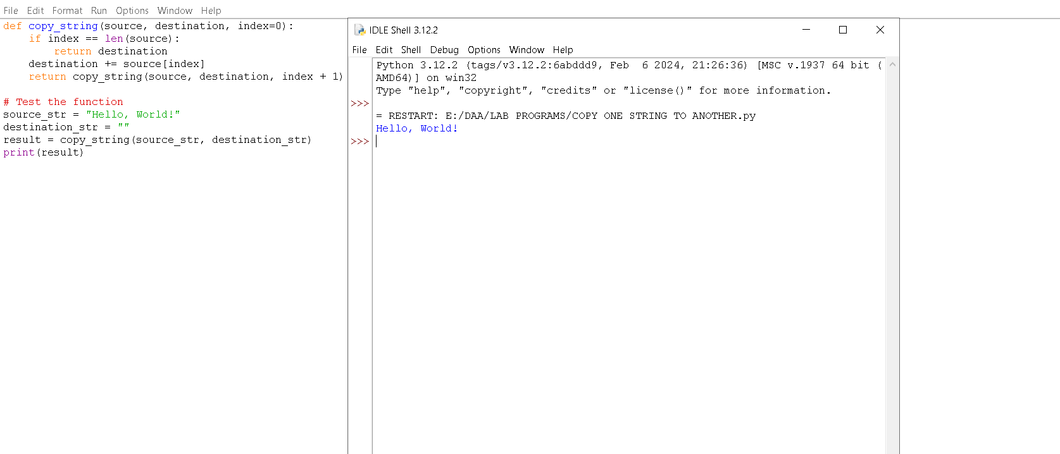

7) the reverse of a string using recursion

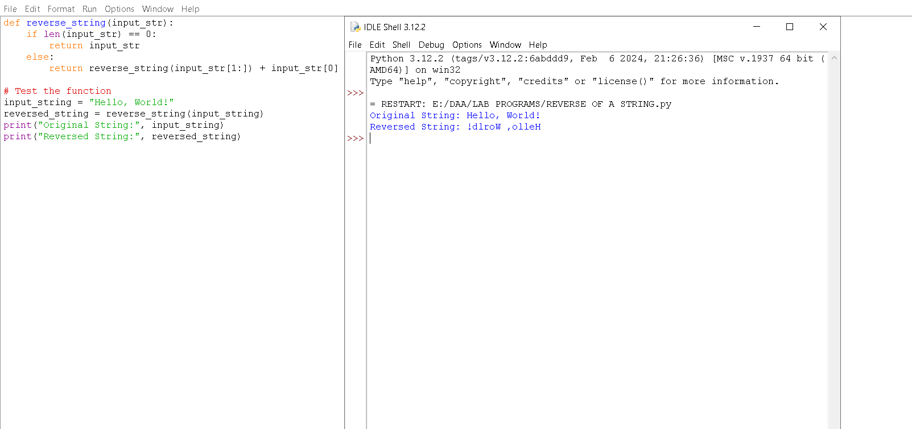

8) generate all the prime numbers using recursion

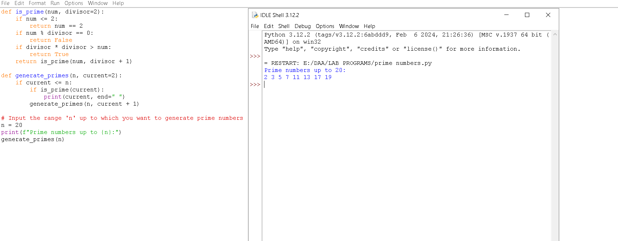

9) to check prime number or not using recursion

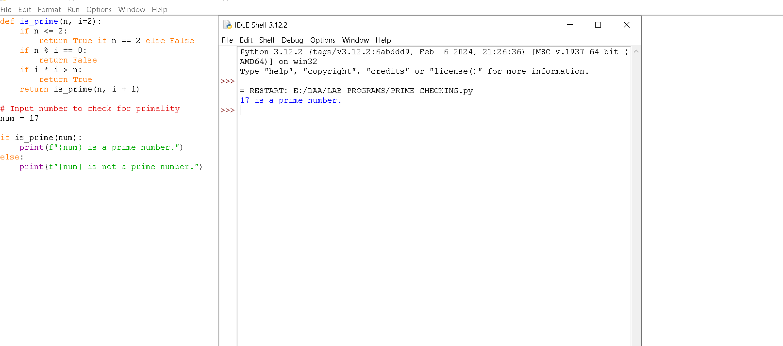

10) to check Palindrome or not using recursions

